SWT 12031: Practical for Object oriented Program
Labsheet 03
Reg. Number: SEU/IS/20/ICT/084
Academic Year :2020/2021
Date: 2023.02.03
Practical No : 03
Department of Information and Communication Technology
Faculty of Technology

Exercise 01:
1. Create your first java program that will print, “Hello, Welcome to Object Oriented Programming!”.
a. Make the name of the class as ‘HelloWorld’.
b. Write the main method that will execute the print statement given.
c. Save the program by giving the file name same as class class and with the .java extension.
d. Compile the program you created.
e. Execute the program you created.

public class HelloWorld{
public static void main (String []args){
System.out.println("Hello World");
}
}

Output :
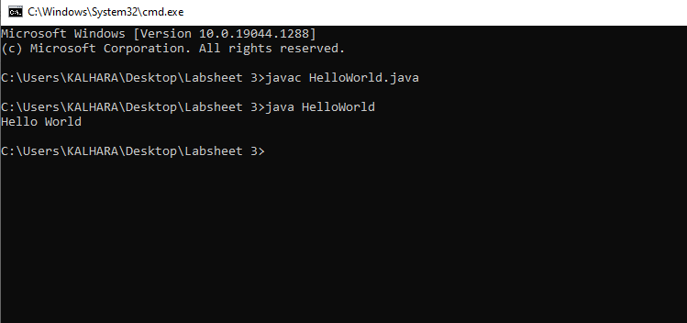

2. Create a class to display the following.

Name : Sam
Subject: OOP
Duration : 4 Months
Grade : A+
public class HelloWorld{
public static void main (String []args){
System.out.println("Name : Sam");
System.out.println("Subject: OOP");
System.out.println("Duration : 4 Months");
System.out.println("Grade : A+");

}
}

Output:
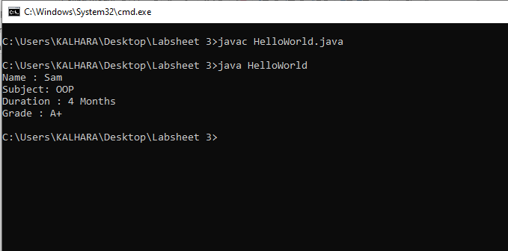

Exercise 02:
1. Create a class called Student. Within this class,
a. Define two variables namely id and name.
b. Initialize id to 1 and name to Kamal.
c. Create an object s1
d. Access the objects through the variable.
public class Student{
int id = 1;
String Name ="Kamal";
public static void main (String []args){

Student obj =new Student();

System.out.println("Student Id is:" + obj.id);
System.out.println("Student Name is:"+ obj.Name);

}
}
Output:

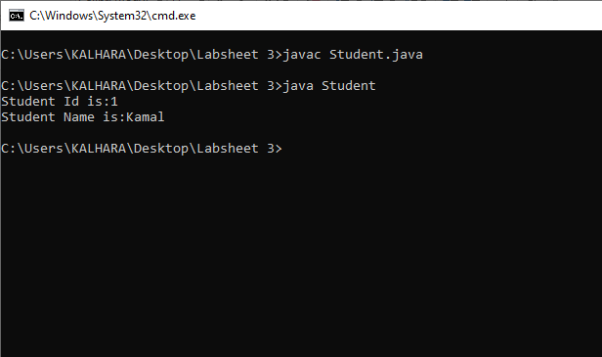

Exercise 03:
1. Create a class called with your name. Within this class,
a. Get the user input for your registration no.
b. Get the user input for your name.
c. Merge and Display both data with the same Output
import java.util.Scanner;
public class Main{
public static void main (String[] args){
Scanner sca =new Scanner(System.in);
Scanner sca2 =new Scanner(System.in);
int reg_no;
String Name;

System.out.print("Enter you registration no:");
reg_no = sca.nextInt();
System.out.print("Enter you Name:");
Name = sca2.nextLine();

System.out.println();
System.out.println("registration no:" +reg_no);
System.out.println("Name:" +Name);

}
}

Output:
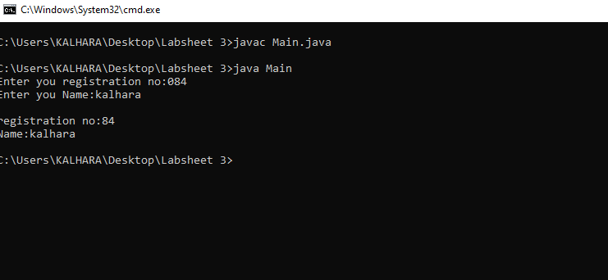
Exercise 04:
1. Create a class called Employee. Within the class,
a. Create the variables empid, name and salary (salary is a float value).
b. Display everything.

public class Employee{
public static void main(String[] args){

String empid ="emp001";
String name ="Job";
float salary =10000.0f;
System.out.println("Employee Id:"+empid);
System.out.println("Employee name:"+name);
System.out.println("Employee salary:"+salary);
}

}
Output :
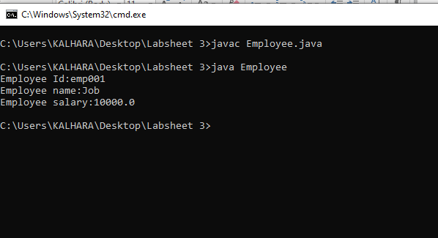

Exercise 05:
- Create a class called MyName to print your name.

public class MyName{
public static void main(String []args){
System.out.println("My name is Kalhara");
}
}
Output:

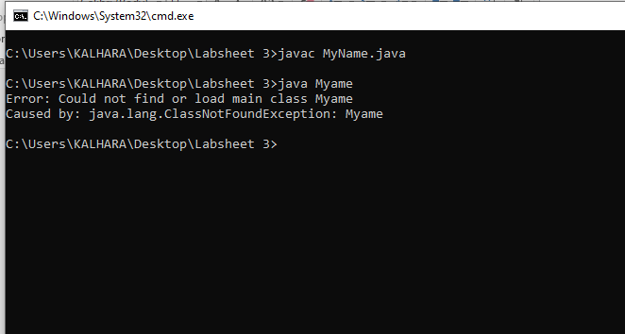

2. Create a class to display the following
Java is an example for OOP
It is a pure Object Oriented language

public class MyClass{
public static void main(String[] args){
System.out.println("Java is an example for OOP ");
System.out.println("It is a pure Object Oriented language");
}
}

Output:
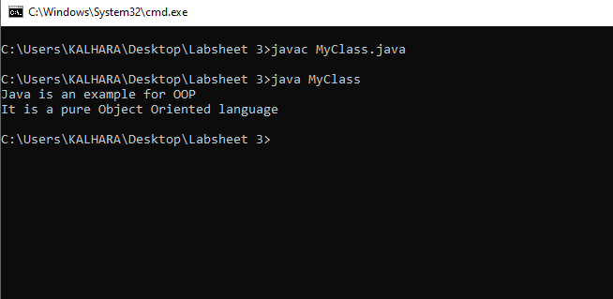

3.
• Create a class called Rectangle. Within the class,
I. Create the variables length and width.
II. Find the Area of the rectangle.

public class Rectangle{
public static void main (String []args){
int length = 50;
int width =100;
int Area;
Area =length*width;
System.out.println("Area is:"+Area);
}
}
Output:
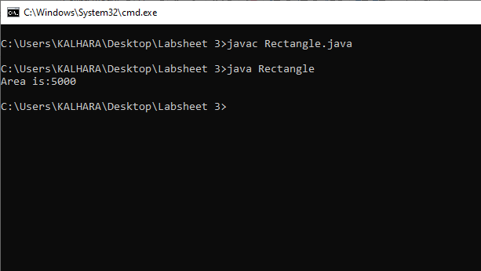

Exercise 06:
Exercise 06:

Write a Java program to calculate a bike’s average consumption from the given total
distance (integer value) traveled (in km) and spent fuel (in liters, float number – 2 decimal point).
Hint :- (distance/Fuel liters)

public class Average{
public static void main (String []args){

float distance = 500;
float Fuel_liters=100;
float average;
average =distance/Fuel_liters;
System.out.println("Average is:"+average);
}
}

Output:
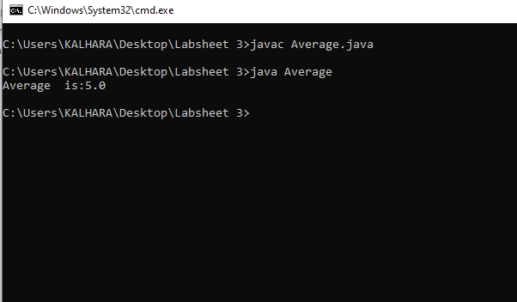

Exercise 07:
Write a Java program to print the following characters in a reverse way.
Test Characters: 'X', 'M', 'L' -> ‘L’,’M’,’X’

public class Characters{
public static void main (String[] args){
char x='L',y ='M',z='X';
System.out.println("X,M,L->"+x+","+y+","+z );
}
}
Output:
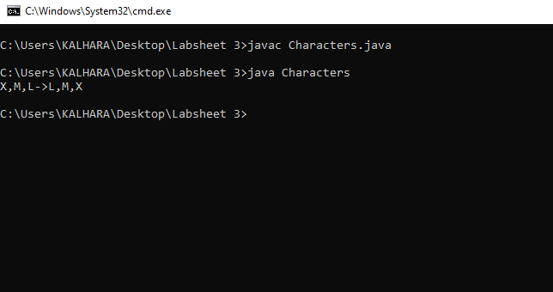

Exercise 08:
Write a java program to read 05 numbers from the keyboard and find their sum and average

import java.util.Scanner;

public class Ex8{
public static void main(String []args){
int num1,num2,num3,num4,num5,sum;
float avg;
Scanner NUM1 = new Scanner(System.in);
System.out.print("Enter you Number 1:");
num1 =NUM1.nextInt();
System.out.print("Enter you Number 2:");
num2 =NUM1.nextInt();
System.out.print("Enter you Number 3:");
num3 =NUM1.nextInt();
System.out.print("Enter you Number 4:");
num4 =NUM1.nextInt();
System.out.print("Enter you Number 5:");
num5 =NUM1.nextInt();

sum =num1+num2+num3+num4+num4;
avg =sum/5;
System.out.println("Sumery is:"+sum);
System.out.println("Average. is:"+avg);
}
}

Output:
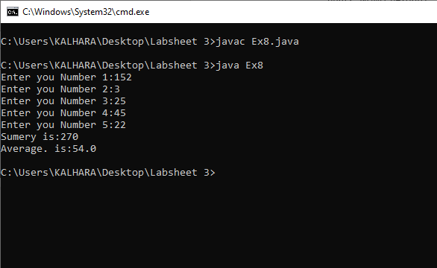

Exercise 09:
Write the java program to Print all elements of 2d array given below the numbers Using for Loop

public class Ex9{
public static void main(String[] args){
int [][] Ar={{1,-2,3,-4},{-5,6,9,7}};
for (int x=0;x<Ar.length;++x){
for(int y=0;y<Ar[x].length;++y){
System.out.println(Ar[x][y]);
}
}
}
}

Output:

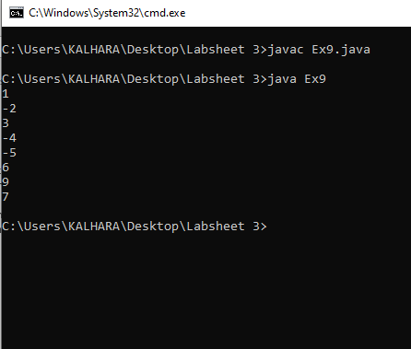

Exercise 10:
Write the java program to print given below the patterns

a.
public class Patten{
public static void main(String[] args){
int i,j,n=6;
for(i=0;i<n;i++){
for (j=2*(n-i);j>=0;j--){
System.out.print(" ");
}
for(j=0;j<=i;j++){
System.out.print("* ");
}
System.out.println();
}
}
}

Output:
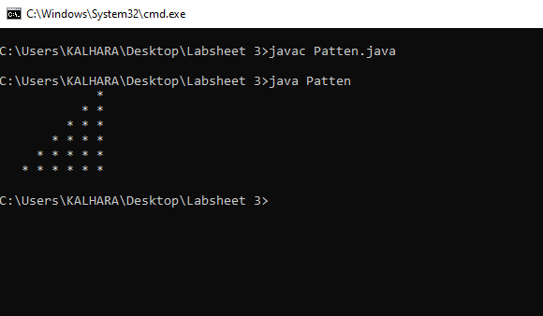

b. public class PattenB{
public static void main(String[] args){
int x,y,num=1,c=7;
for(x=0;x<c;x++){
for(y=0;y<=x;y++){
System.out.print(num+" ");
num++;
}
System.out.println();
}
}
}

Output:
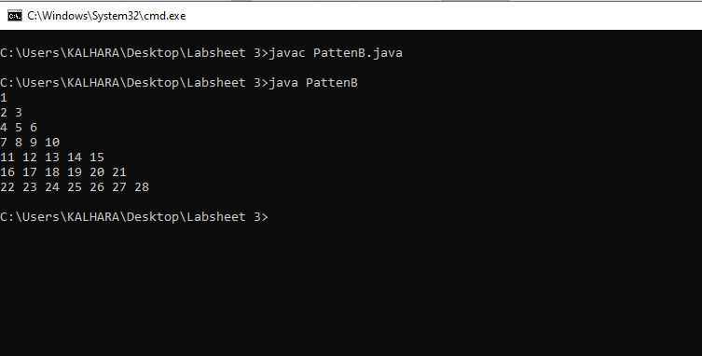
c.
public class PattenC{
public static void main(String[] args){
int x,y,alphabet =65;
for(x=0;x<=9;x++){
for(y=0;y<=x;y++){
System.out.print((char) alphabet+" ");
}
alphabet++;
System.out.println();
}
}
}
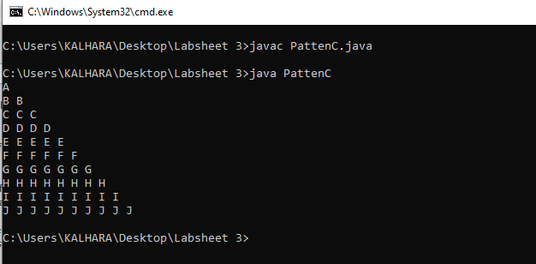
Output:

Discussion
• Class.
• Variable.
• Single Array.
• 2D Array
• 3D Array
• Reverce in java.
• Star Pattern
• Number Pattern
• Character Pattern

